Chapter 10, Problem 17.

By nodal analysis, obtain current I_{o} in the circuit in Fig. 10.66.

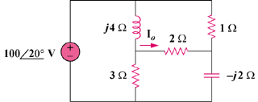

Figure 10.66
For Prob. 10.17.

